**DIFFERENT CONVOLUTIONAL NETWORK ARCHITECHTURES ON**

**IMAGENET32**

1. **Build the best network using Keras –**

Since the dataset is huge and requires very high computational capacity, we could only run a few epochs in the range of 5-25. The best network we could build on this dataset was with 6 convolutional layers, 3 Max pooling layers and 3 fully connected layers. The network configuration and outcome is given below –

Epochs – 10

Activation – Relu

Optimizer – Adamax

Batch Size – 128

CNN Layers – 64, 64, 256, 256, 128, 128

FC layers – 256, 512, 200

Dropout – 0.35

The Testing accuracy is 31.38% and training accuracy is 30.29

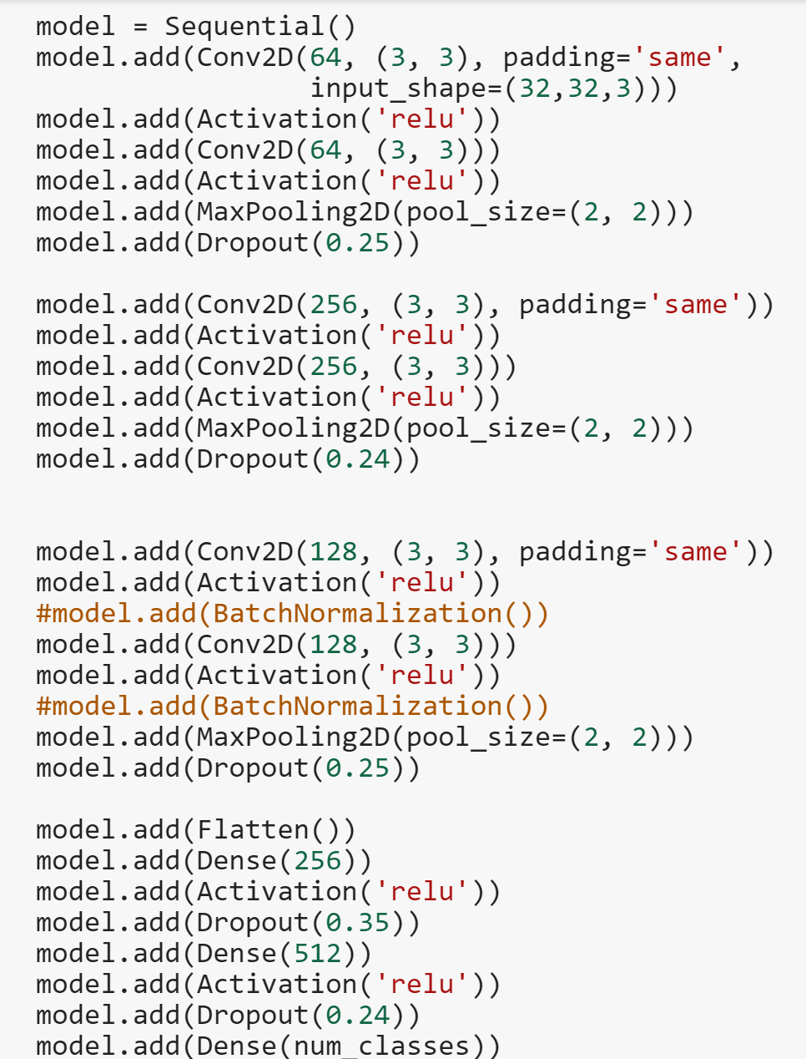

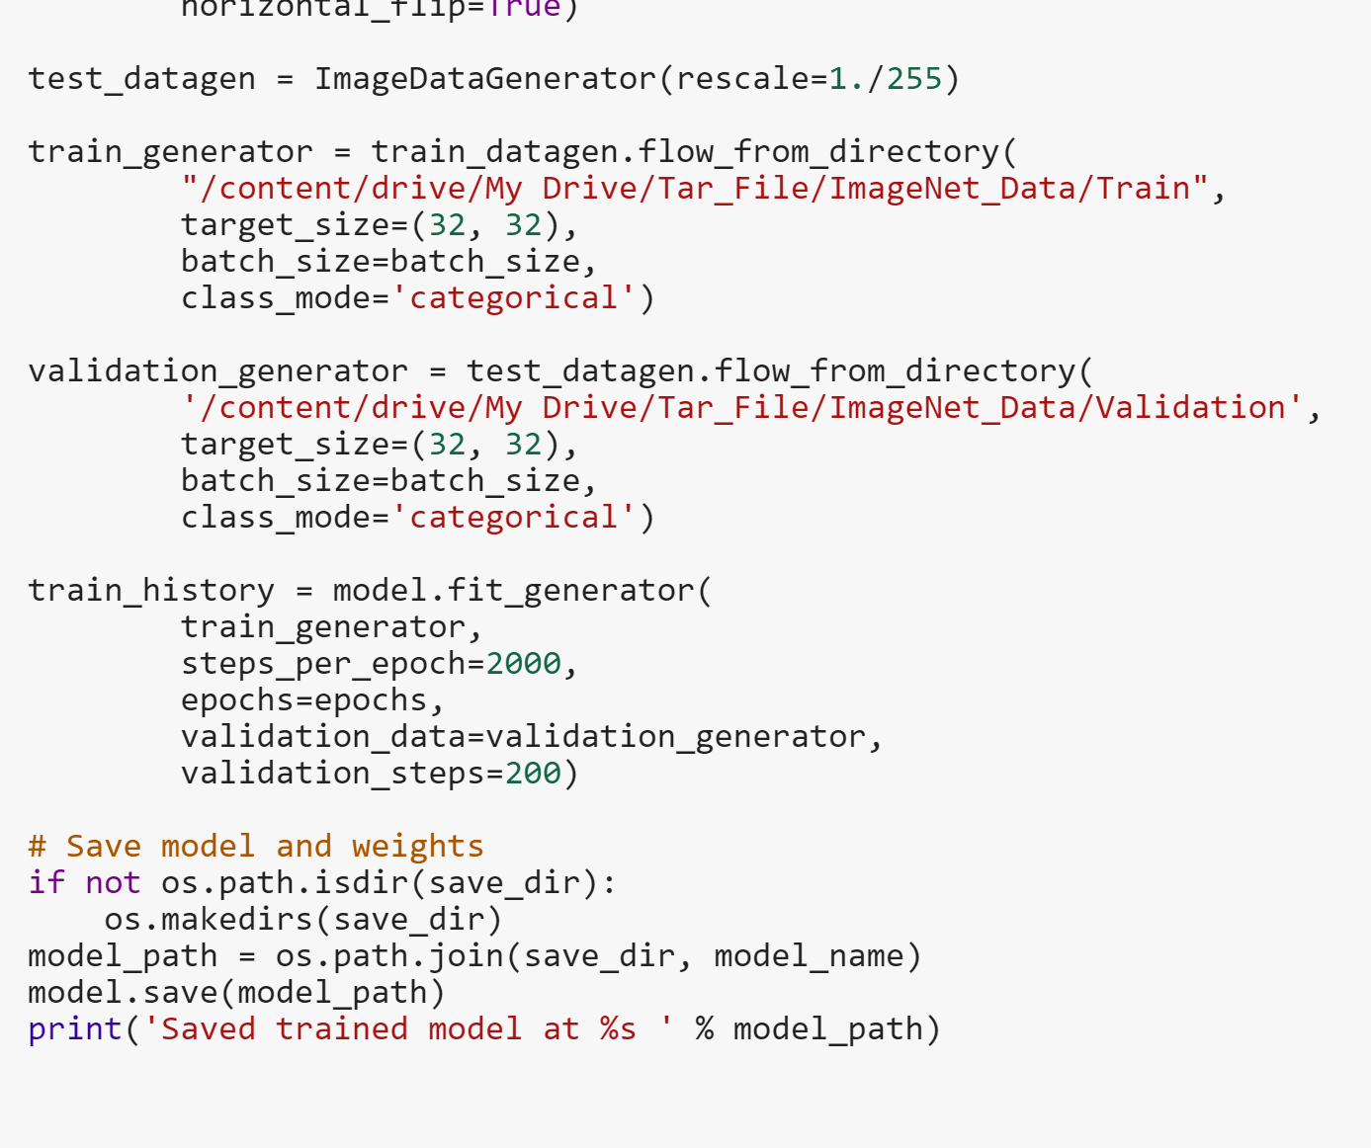

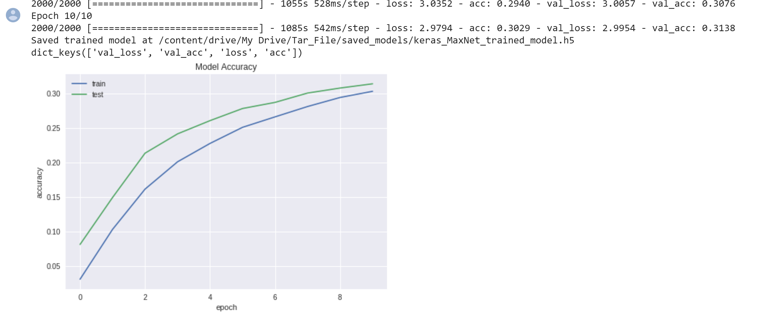

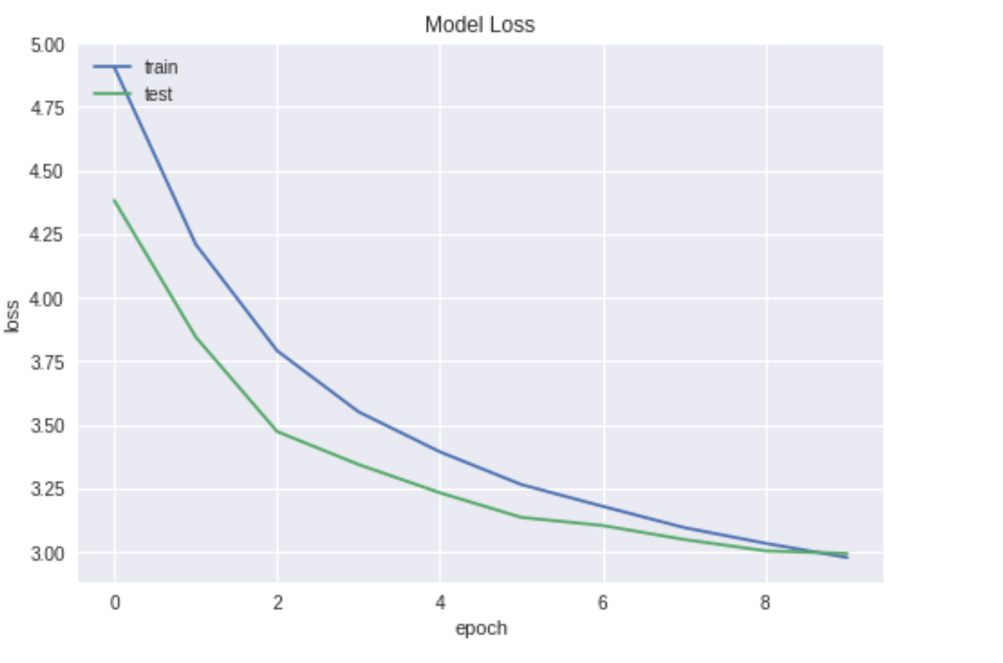

The accuracy is converging and will increase further if we train it for more epochs using GPU.

Prediction on Test Image –

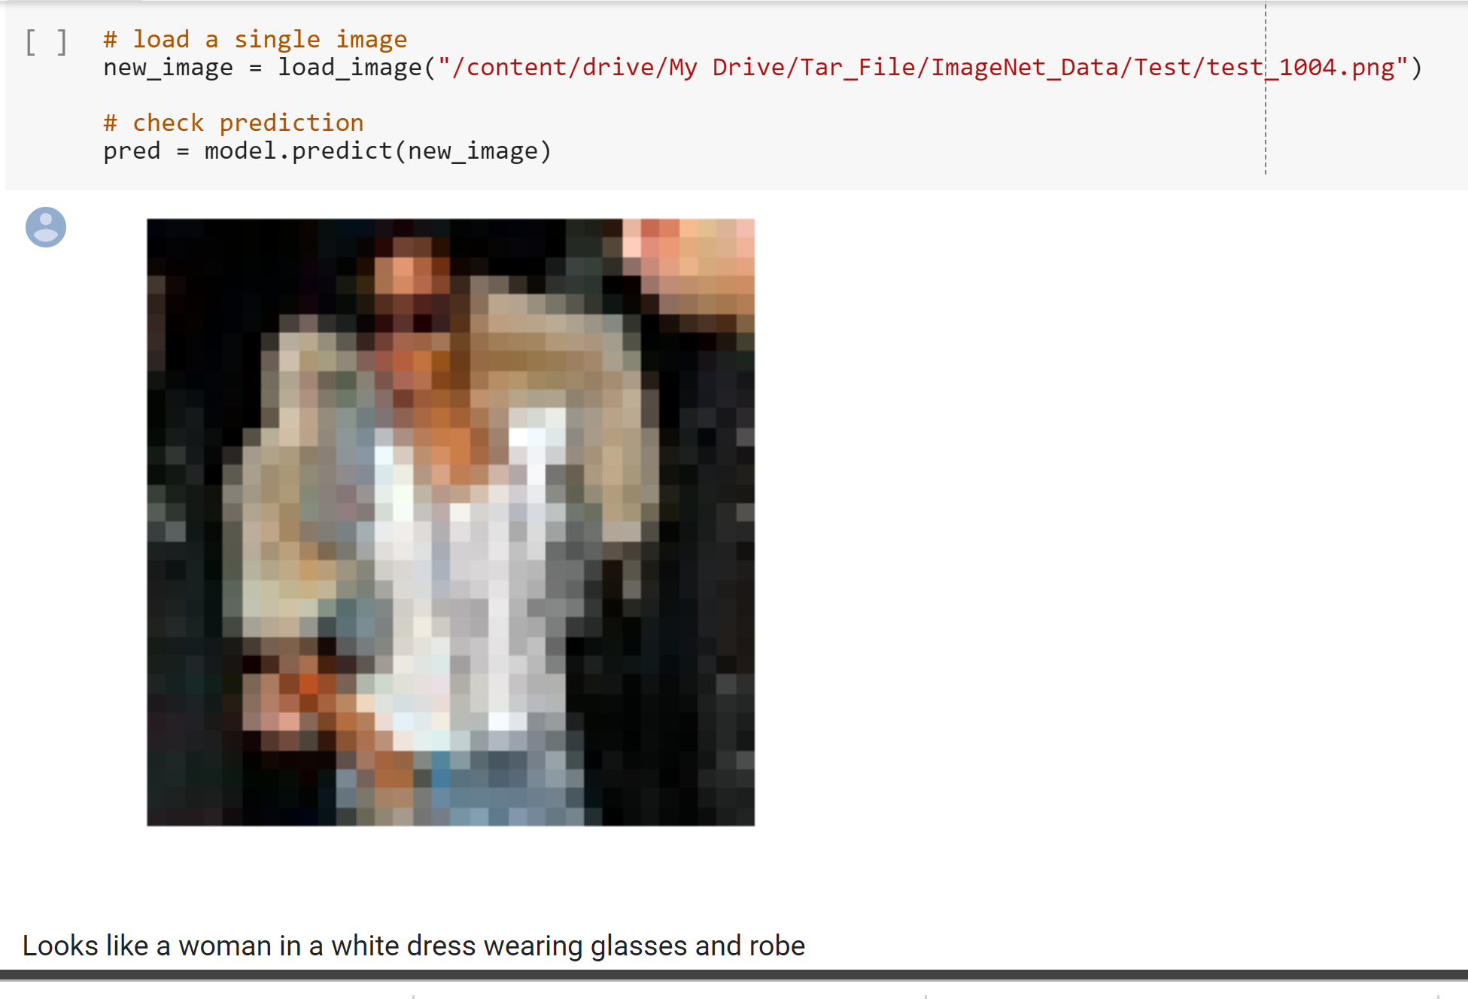

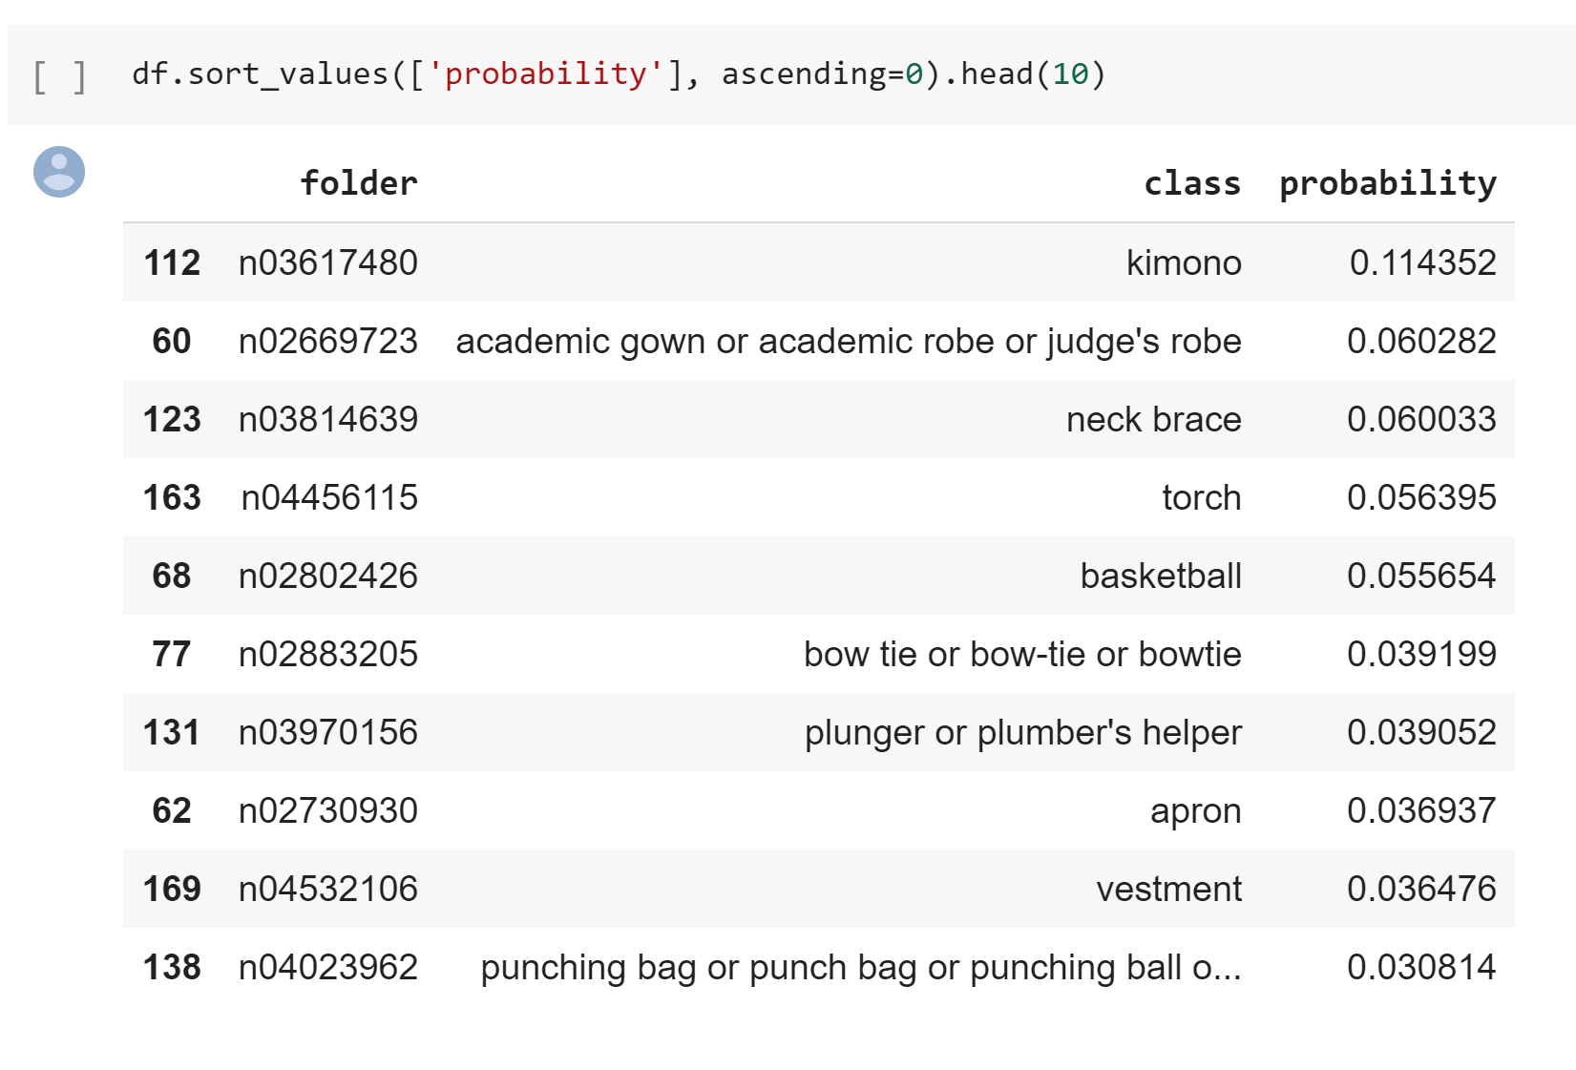

**2. Applied Transfer Learning using Densenet121 pretrained model on CIFAR10 –**

The network configuration and outcome is given below –

Epochs – 5

Activation – Swish , Relu

Optimizer – Adamax

Batch Size – 16

CNN Layers – 12 layers from the Densenet

FC layers – 512, 512, 10

Dropout – 0.35

The Testing accuracy was 76.98% and training accuracy was 86.06% with just a epoch of 5. Swish gave a better accuracy than Relu, as Swish works better with deeper networks like these. But Relu is computationally less expensive than Swish.

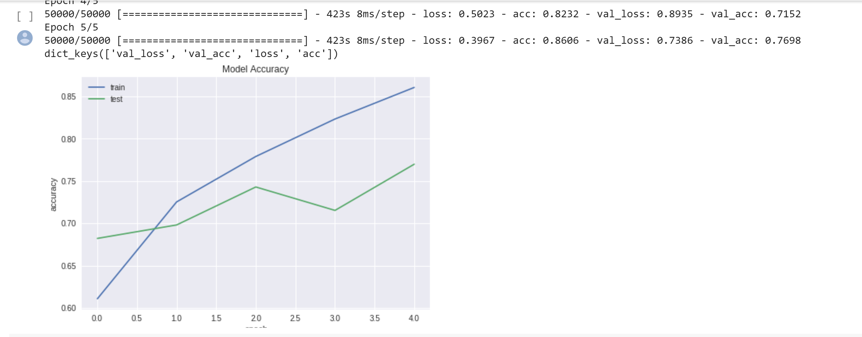

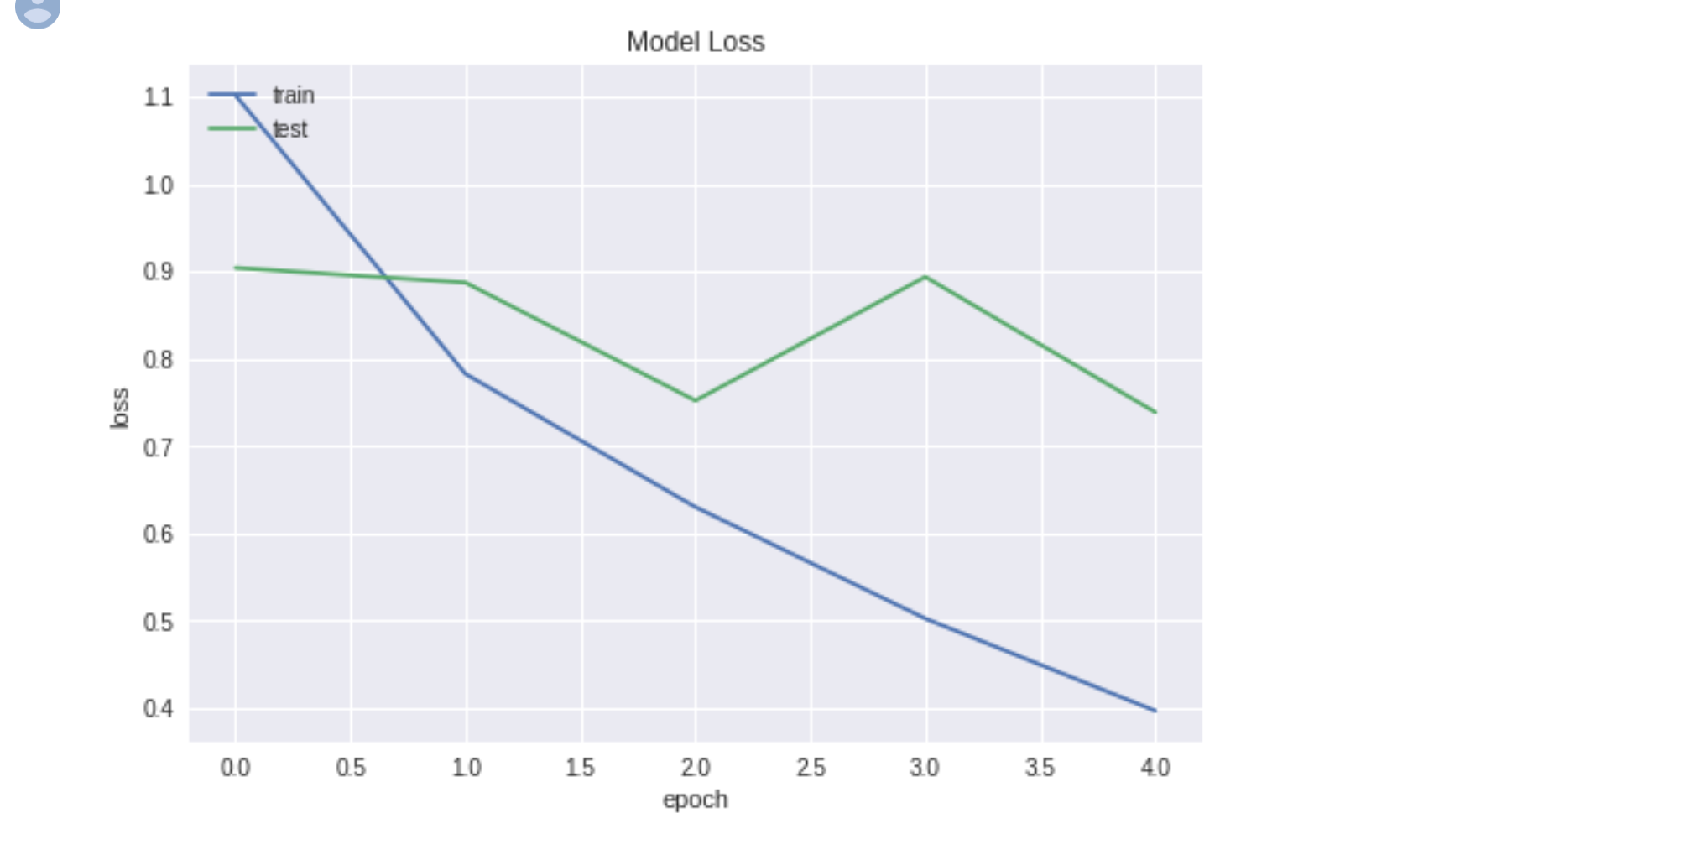

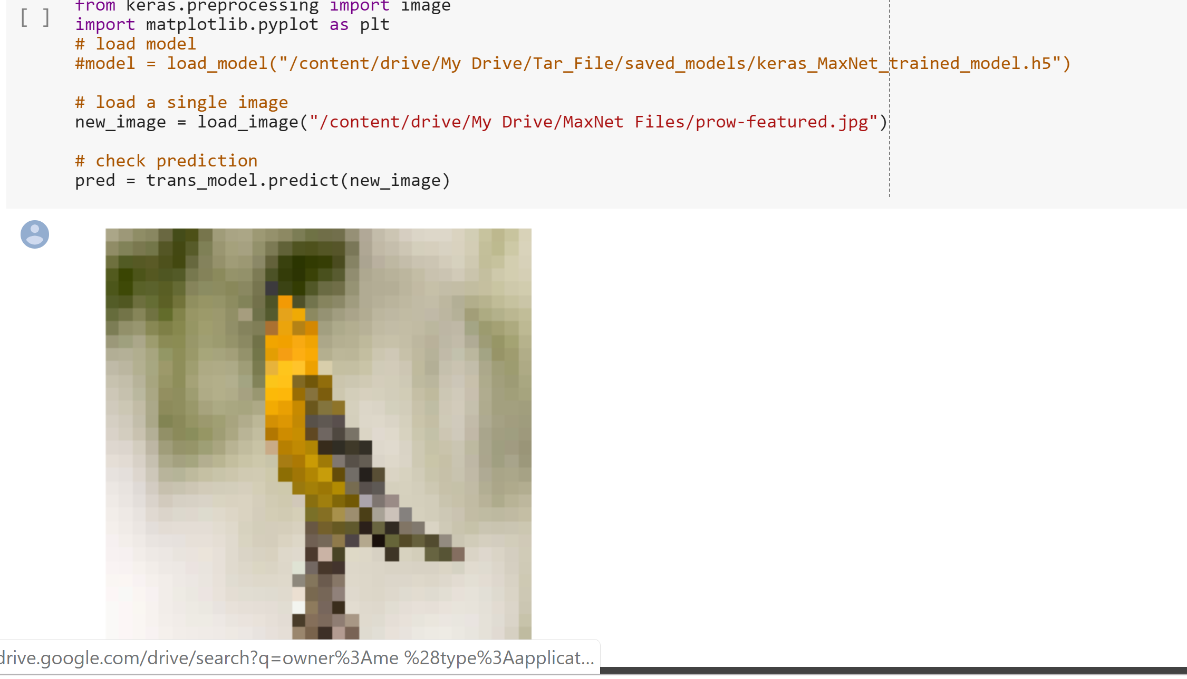

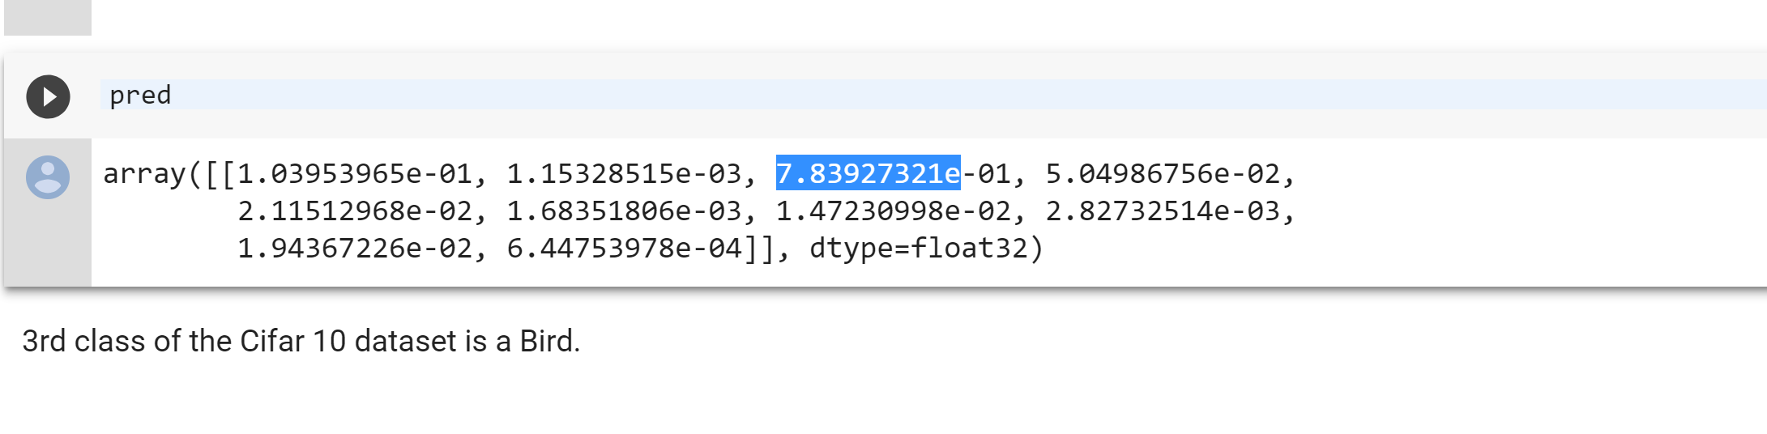

The corresponding probability for Bird class is 78%, so it predicted the test image very closely.

**Using Relu –**

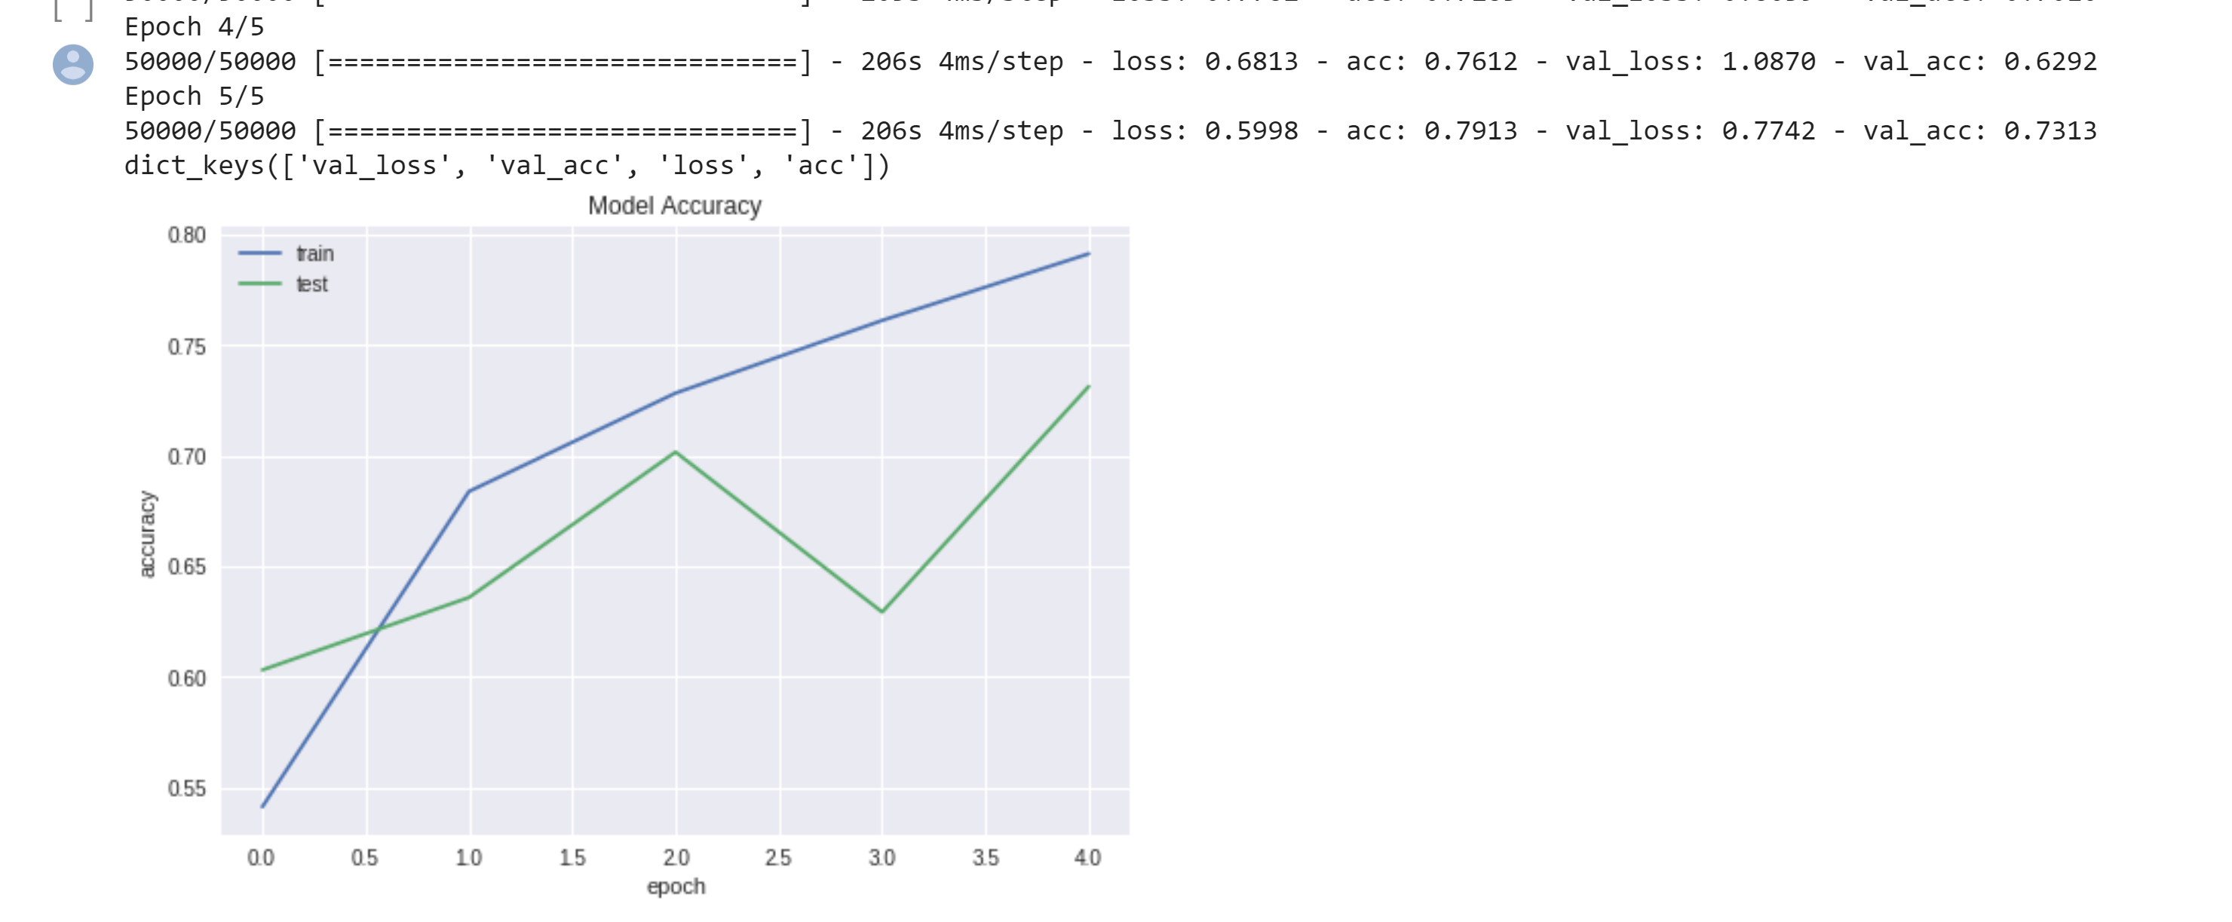

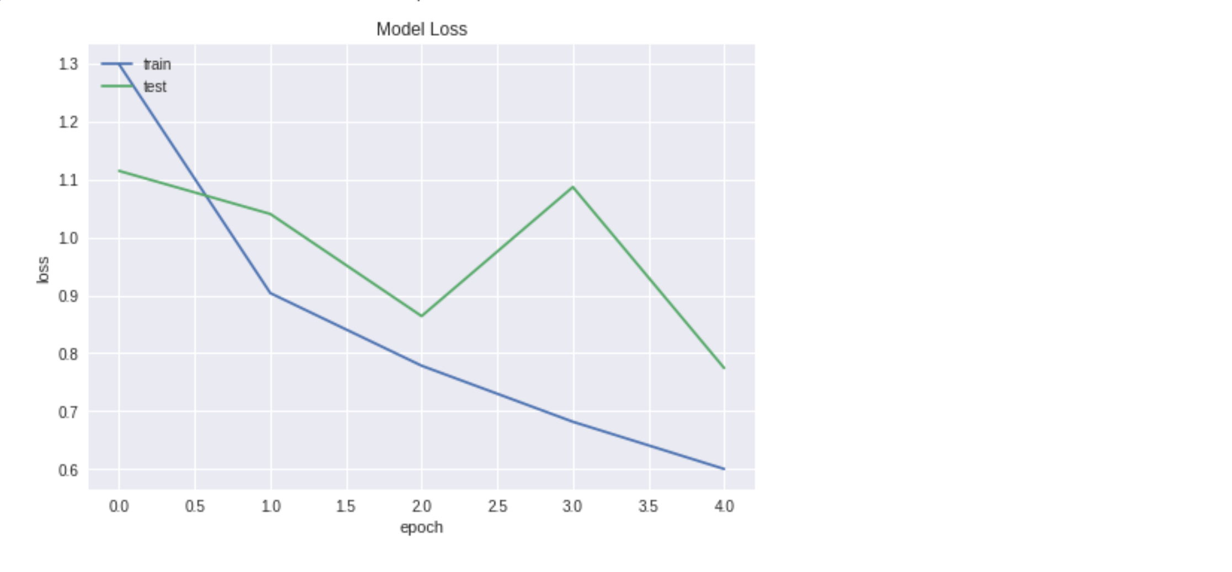

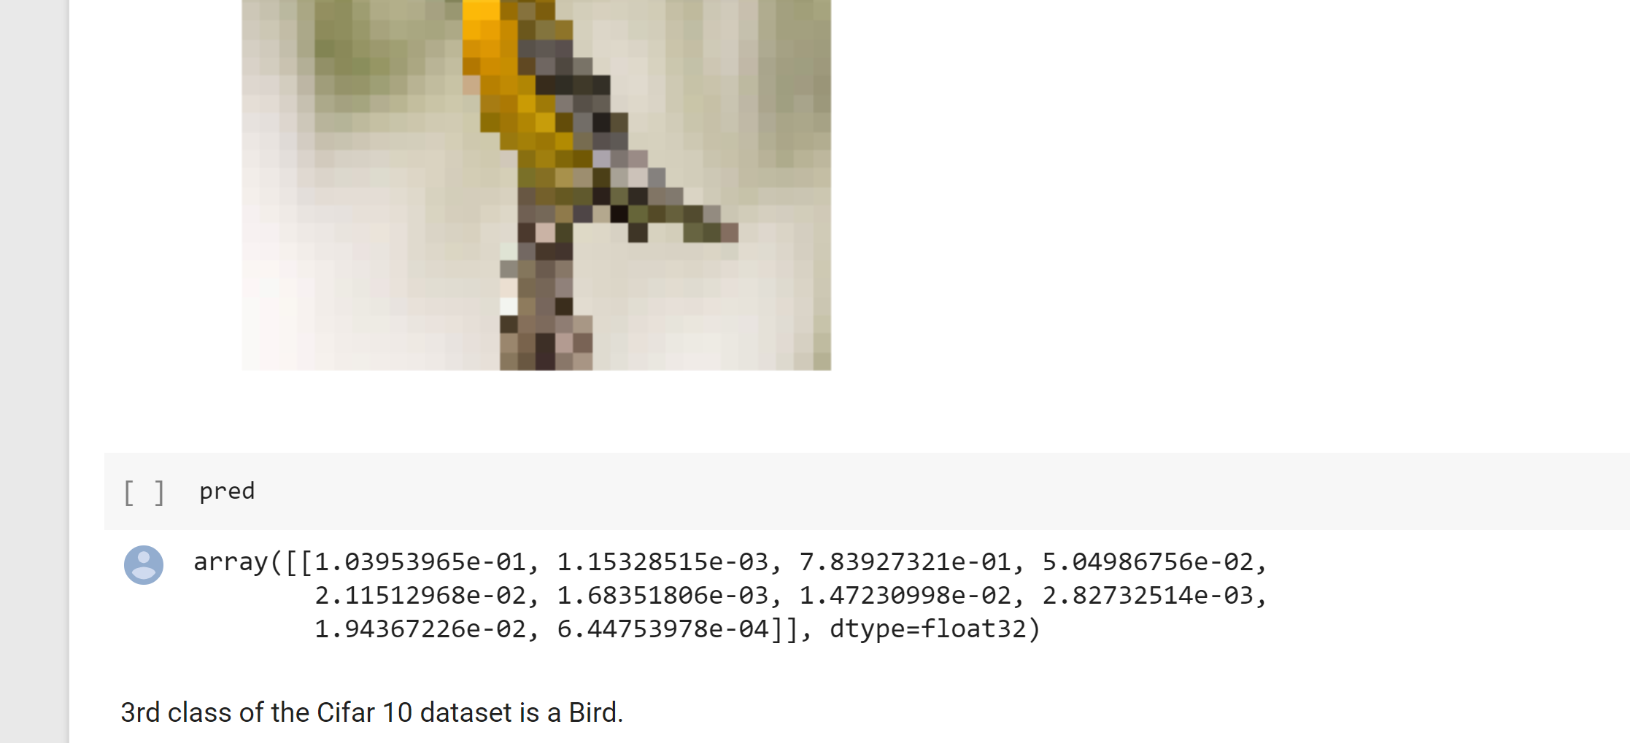

**3. Used AutoKeras to Tune Hyperparameters –**

Since the dataset is huge and requires very high computational capacity, we could only run a few epochs even after letting the Autokeras run for 10 hours on GPU. We compared the performance and speed on ImageNet and Cifar10.

Image Net -

Epochs – 20, 28 (2 Models)

The best accuracy was 24.4% on ImageNet and 88.6% on Cifar10 , This shows that Image net is a way more complex dataset than Cifar10 and it will take much denser network configurations to learn the representations.

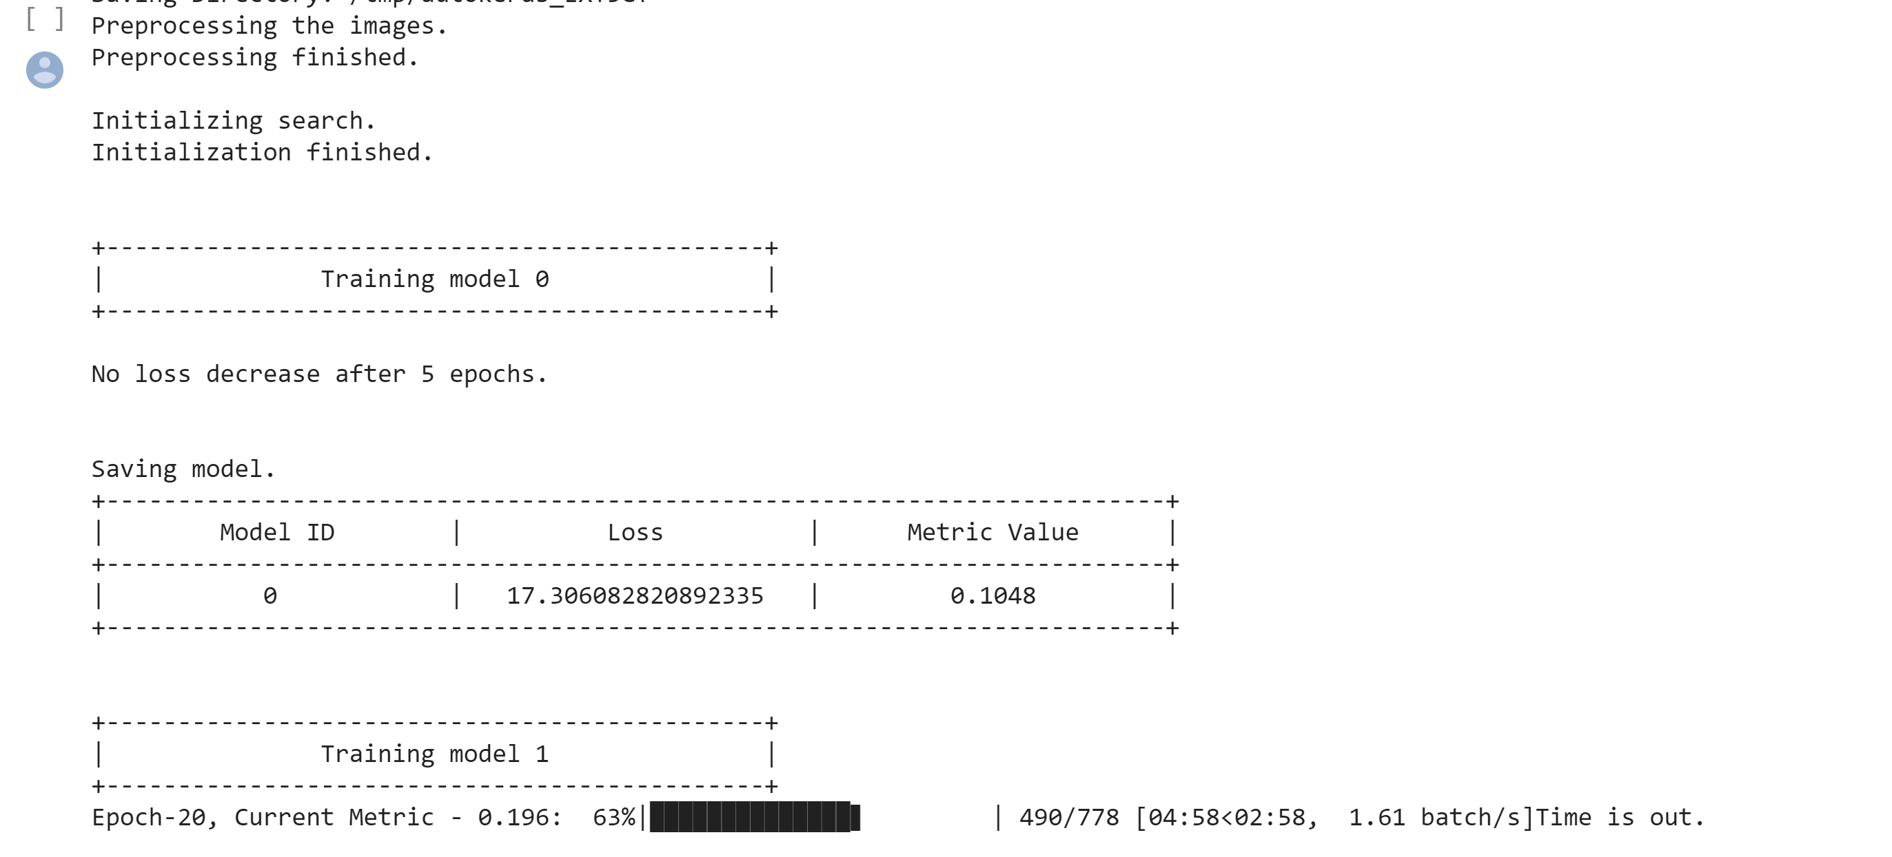

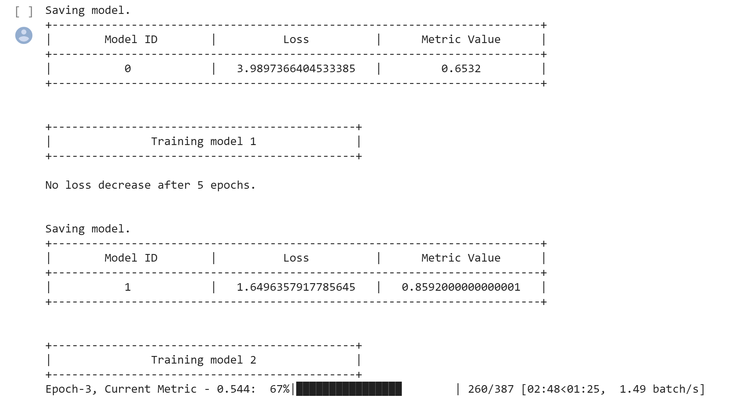

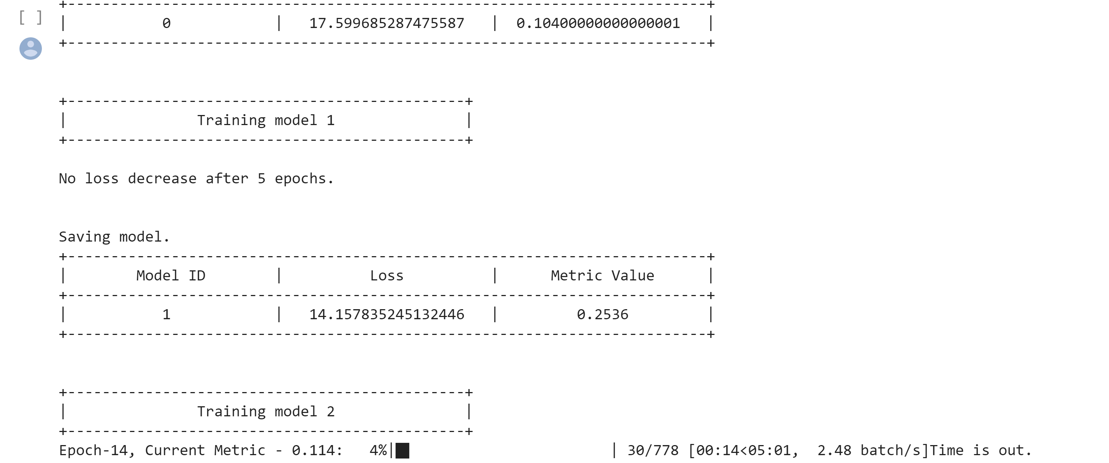

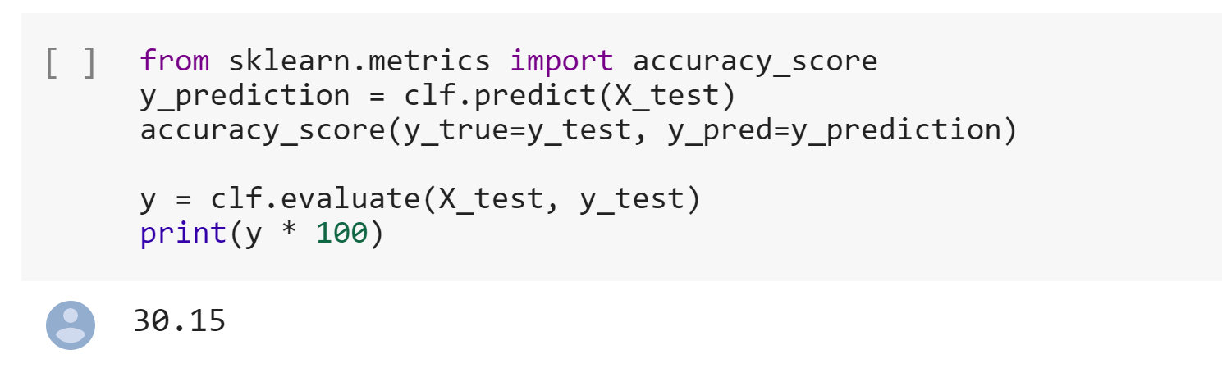

1. **Implemented the AlexNet Architechture –**

The network configuration of the AlexNet and outcome is given below –

Epochs – 10

Activation – Relu

Optimizer – Adamax

Batch Size – 128

CNN Layers – 96. 256, 384, 384, 256

FC layers – 4096, 4096, 1000, 200

Dropout – 0.4

The Alexnet uses Dropout for avoiding overfitting, Batch normalization was developed after this so that was not used in the architecture. As we can see the computation is huge as it involves some 76 million trainable parameters.

The Accuracy we got was 0.05 with only 1 epoch. This can be a great model if we have good capacity to run on multiple GPUs. This was how it was ran in the original paper as they distributed the layer computations on different GPUs.

